NAME: عمر عبدالله السعيد عبدالمجيد

SECTION:24

ID: 535

# TOBIC: ARTIFICIAL INTILLIGENCE

## APP.BRIEF:

Artificial Intelligence enhances the speed, precision and effectiveness of human efforts. In financial institutions, AI techniques can be used to identify which transactions are likely to be fraudulent, adopt fast and accurate credit scoring, as well as automate manually intense data management tasks.

# 

# Artificial Intelligence

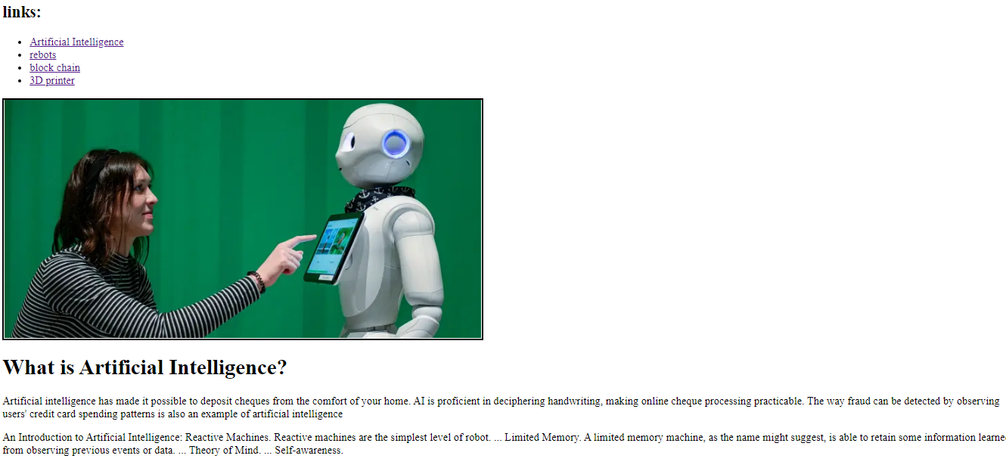

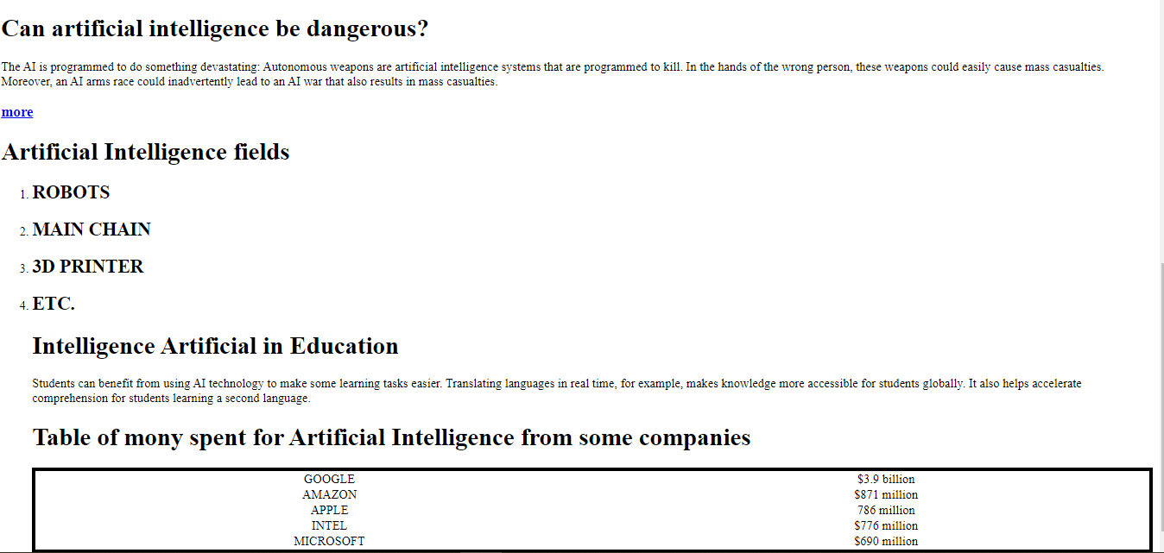

# 

# 



Bitcoin blockchain structure A blockchain is a growing list of records, called blocks, that are linked together using cryptography.[1][2][3][4] Each block contains a cryptographic hash of the previous block, a timestamp, and transaction data (generally represented as a Merkle tree). The timestamp proves that the transaction data existed when the block was published in order to get into its hash. As blocks each contain information about the block previous to it, they form a chain, with each additional block reinforcing the ones before it. Therefore, blockchains are resistant to modification of their data because once recorded, the data in any given block cannot be altered retroactively without altering all subsequent blocks.

The blockchain was invented by a person (or group of people) using the name Satoshi Nakamoto in 2008 to serve as the public transaction ledger of the cryptocurrency bitcoin.[3] The identity of Satoshi Nakamoto remains unknown to date. The invention of the blockchain for bitcoin made it the first digital currency to solve the double-spending problem without the need of a trusted authority or central server. The bitcoin design has inspired other applications[3][2] and blockchains that are readable by the public and are widely used by cryptocurrencies. The blockchain is considered a type of payment rail.[6] Private blockchains have been proposed for business use but Computerworld called the marketing of such privatized blockchains without a proper security model "snake oil".[7] However, others have argued that permissioned blockchains, if carefully designed, may be more decentralized and therefore more secure in practice than permissionless ones.[4][8]

video

more

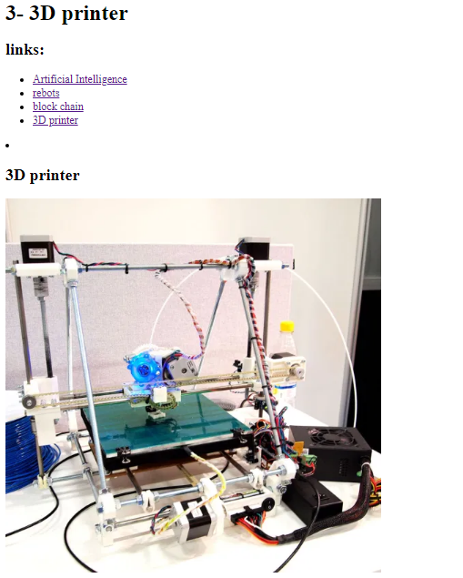

3D printing, or additive manufacturing, is the construction of a three-dimensional object from a CAD model or a digital 3D model.[1] The term "3D printing" can refer to a variety of processes in which material is deposited, joined or solidified under computer control to create a three-dimensional object,[2] with material being added together (such as plastics, liquids or powder grains being fused together), typically layer by layer.

In the 1980s, 3D printing techniques were considered suitable only for the production of functional or aesthetic prototypes, and a more appropriate term for it at the time was rapid prototyping.[3] As of 2019, the precision, repeatability, and material range of 3D printing have increased to the point that some 3D printing processes are considered viable as an industrial-production technology, whereby the term additive manufacturing can be used synonymously with 3D printing.[4] One of the key advantages of 3D printing is the ability to produce very complex shapes or geometries that would be otherwise impossible to construct by hand, including hollow parts or parts with internal truss structures to reduce weight. Fused deposition modeling (FDM), which uses a continuous filament of a thermoplastic material, is the most common 3D printing process in use as of 2020.[5]

[**video**](https://3dprinting.com/what-is-3d-printing/)

[**more**](https://en.wikipedia.org/wiki/3D_printing)

